

CYBERSECURITY SUMMARY REPORT (CSR)

Cisco Global Certification Team (GCT) Defense Programs (DP) Internal Compliance Review (ICR) Cybersecurity Summary Report (CSR) For Cisco Session Border Controller (SBC)

Version | Date | Change Description
1.0 | March 2026 | Initial Report

CYBERSECURITY SUMMARY REPORT

- SYSTEM TITLE. Cisco Session Border Controller (SBC), Software Release IOS XE 17.18.

- SUMMARY. Table 1a depicts critical testing requirements and summarizes the findings that were identified during Cybersecurity (CS) testing. A finding is a discrepancy requiring investigation for a potential vulnerability that could be used to exploit the system. An analysis of each finding must be conducted to determine its impact to the overall security posture of the System Under Test (SUT). The findings listed in the column “without Required Ancillary Equipment (RAE) (W/O-RAE)” are the total number of findings present within the system. These findings will be present if a defense-in-depth strategy or any other mitigation is not applied by the site acquiring this product. The findings in the column “with RAE (W-RAE)” are the number of findings within the system when it is configured with external security devices and other noted Conditions of Fielding as specified in Paragraph 9. The external devices for this system are Active Directory (AD), Public Key Infrastructure (PKI), and Syslog Server, which are designated as RAE. In Paragraph 10, "Test Results and CS Findings," details each finding on this SUT and includes the vendor-provided mitigation strategy for each finding. Table 1b depicts the Internet Protocol (IP) Vulnerability (IPV) test summary identified in Phase II IPV testing. This SUT encryption module is subject to comply with Federal Information Processing Standard (FIPS) 140. Table 1c depicts the status of the FIPS certification.

Table 1a. CS Test Summary

Component | Critical | W/O-RAE | W-RAE
SBC | Yes | 6 CAT I  29 CAT II  No CAT III | No CAT I  No CAT II  No CAT III
IWBC | Yes | 6 CAT I  29 CAT II  No CAT III | No CAT I  No CAT II  No CAT III
IWG | Yes | 6 CAT I  29 CAT II  No CAT III | No CAT I  No CAT II  No CAT III
Total Findings |  | 18 CAT I  87 CAT II  No CAT III | No CAT I  No CAT II  No CAT III

Table 1b. IP Vulnerability Test Summary

Requirement (See note.) | Date | Total Findings
IP Vulnerability | November 2023 | No High Risk  No Medium Risk  No Low Risk
NOTE: Requirements are derived from DoDI 8500.1 and DoDI 8551.1.

Table 1c. Cryptographic Module Validation Program (CMVP) Status Summary

CMVP# | Module Name | Components | Status | Sunset Date
4752 | IOS Common Cryptographic Module (IC2M) Module | IWBC | Active | 08/06/2029
 |  | IWG
 |  | SBC
4747 | Cisco FIPS Object Module | IWBC | Active | 07/31/2029
 |  | IWG
 |  | SBC
NOTE: National Institute of Standards and Technology (NIST) CMVP Module search/information site:
https://csrc.nist.gov/projects/cryptographic-module-validation-program/validated-modules/search/.

- SYSTEM DESCRIPTION
- General Description. The Cisco Session Border Controller (SBC) facilitates Internet Protocol (IP) to IP Assured Services-Session Initiation Protocol (AS-SIP) communications between session controllers (SC) that support the Unified Capabilities Requirements (UCR) Alternative B failover method and their end instruments, when traversing the UC Network. The SBC interfaces with Defense Information Systems Network Unified Capabilities (DISN UC) systems through an AS-SIP interface and provides IP to IP communications between edge (LSC/ESC) and core (Soft Switch) segments in the UC network. Additional functions include AS-SIP Signaling and encryption services to allow end to end communications on the UC Network. This SBC solution consists of the Cisco Integrated Services Router (ISR) 4000 series, Aggregation Services Router (ASR) 1000 series, Catalyst 8000V, Catalyst 8200 Series and Catalyst 8300 Series of hardware platforms.

- Management Description. The SBC is managed using a site-provided Windows workstation that is Security Technical Implementation Guideline (STIG) compliant and enabled for Common Access Card (CAC) authentication. Following initial setup, administrative tasks are carried out over a Secure Shell version 2 (SSHv2) connection. A local emergency account is also configured to ensure access if the Active Directory server is unavailable, with this account adhering to local password complexity policies. The SBC leverages the Identity Services Engine (ISE) to control authentication based on user group membership, integrated with Active Directory (AD) and the network device’s Authentication, Authorization, and Accounting (AAA) functions. During testing, Terminal Access Controller Access-Control System Plus (TACACS+), integrated with AD, was used for these purposes; however, TACACS+ is not required for system operation.

- Components Under Test. Figure 1 illustrates the System Under Test (SUT) configuration, detailing its components and connectivity schemes utilized during the CS assessment. The system is composed of these elements
- SBC
- Combined SBC/IWG Combined (IWBC)
- IWG (Interworking Gateway)

Figure 1. SUT Test Configuration

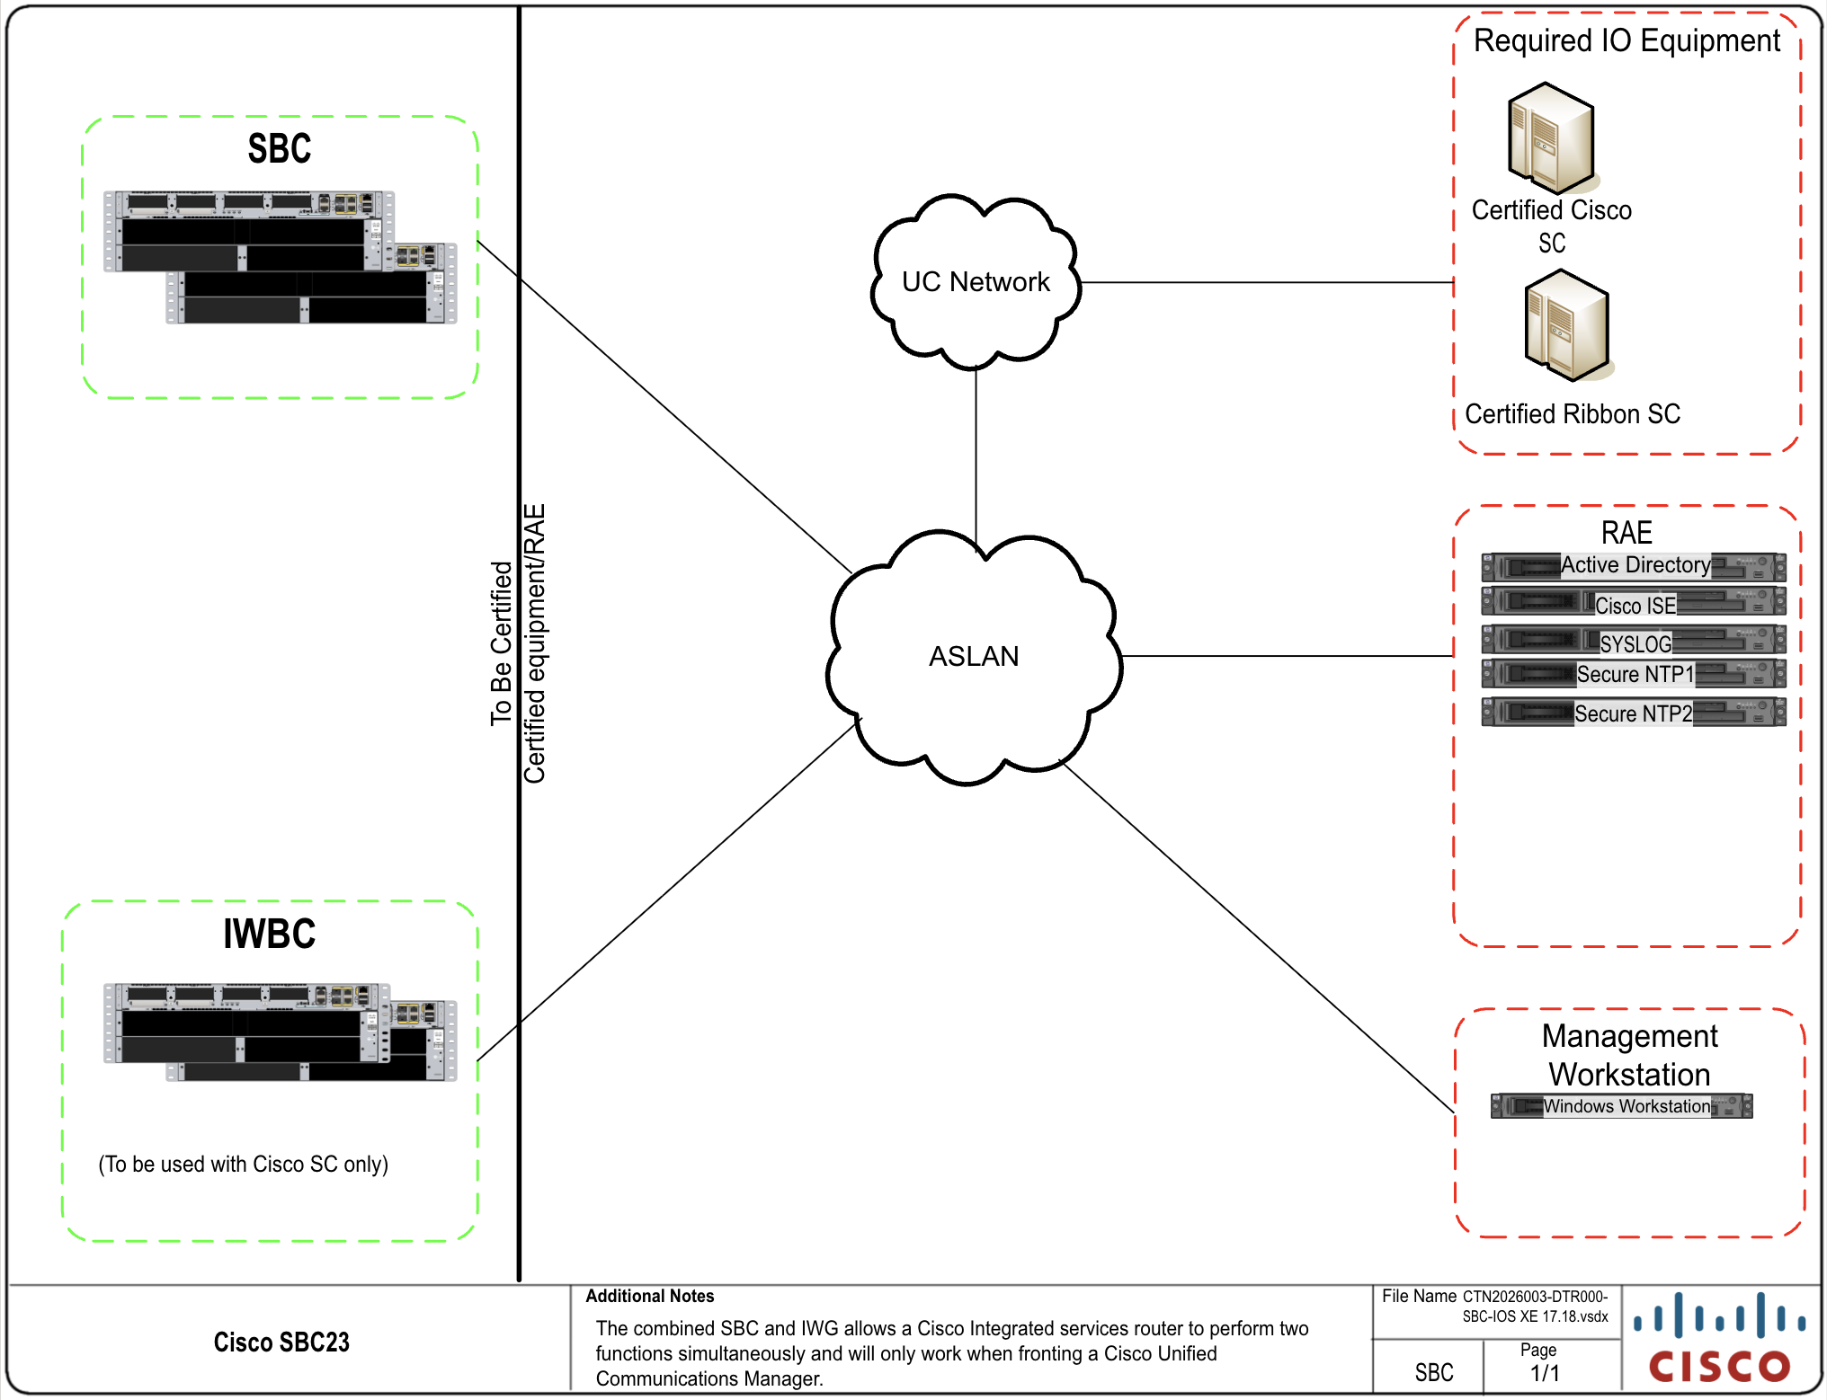

Component 1. Interworking Gateway (IWG) and Session Border Controller (SBC) Combined (IWBC): The Cisco Unified Border Element (CUBE) can be deployed to provide both Interworking Gateway (IWG) functions and Session Border Controller (SBC) functions in a single chassis when deployed with the Cisco Collaborative environments. This capability is available in IOS XE software on all IWG and SBC platforms and has been termed an IWBC by Cisco. All Cisco Session Border Controller (SBC) and Interworking Gateway (IWG) can be deployed in pairs to provide High Availability (HA) and failover redundancy.

Component 2. Session Border Controller (SBC): The Cisco Session Border Controller (SBC) deployment as part of the SS provides critical SIP message normalization
functionality that allows for interoperability between components within the Unified Capabilities architecture. Cisco Session Border Controller (SBC) can be deployed in pairs to provide high availability. This is accomplished by using Hot Standby Protocol

- OPERATIONAL ARCHITECTURE. The DoDIN architecture is structured as a two-level network hierarchy, comprising DISN backbone switches and Service/Agency installation switches. The specific type of switch permitted at any given location is determined by DoD Chief Information Officer and Joint Staff policy, along with subscriber mission requirements. Consequently, the DoDIN architecture incorporates various categories of switches. This notional operational DoDIN architecture, which illustrates where the SUT may be utilized, is depicted in Figure ES.1. UC High Level Operational Framework within the Department of Defense (DoD) Unified Capabilities Master Plan (UC MP).

CYBERSECURITY REQUIREMENTS. Table 2 provides previous and current Desktop Review (DTR) information and result of test. Requirements listed in table 3 are derived from DoD guidance. This table list requirements and findings for IPV testing.

Table 2. Desktop Review Table

Request Date | DTR Number | Description | Results of Testing
March 2026 | Initial | This is an initial request for IOS XE Release 17.18 software for product components SBC, IWG and IWBC. The request includes ASR 1006-X, Cisco Catalyst 8300 Series, Cisco Catalyst 8200 Series, ISR 4461/K9 and Cisco Catalyst 8000v Series. | No testing required.

Table 3. IP Vulnerability Summary

Component | Critical | Plug-in ID # (s) | Findings | Total Findings
SBC | Yes | NA | No High Risks  No Medium Risks  No Low Risks | No High Risks  No Medium Risks  No Low Risks
IWBC | Yes | NA | No High Risks  No Medium Risks  No Low Risks | No High Risks  No Medium Risks  No Low Risks
IWG | Yes | NA | No High Risks  No Medium Risks  No Low Risks | No High Risks  No Medium Risks  No Low Risks
Total Findings |  |  |  | 0 Findings

- SYSTEM CONFIGURATIONS. Table 4 provides the system configuration, detailing the hardware and software components that were tested. It also lists the components within the family series that, although not tested, are certified based on their similarity.

Table 4. SUT Hardware/Software/Firmware Version Identification

System Name | Hardware/Software Release
Required Ancillary Equipment | Active Directory
 | Public Key Infrastructure
 | SysLog Server
 | Network Time Protocol (NTP) Servers
Product Component | Hardware | Card Name/Part Number/ Part Name/VM | Software Firmware | Hardware certified by Similarity
SBC | C8000v | ESXi Server Host | IOS XE 17.18 | NA
SBC | C8200-1N-4T | NA | IOS XE 17.18 | C8200L-1N-4T
SBC | C8300-1N1S-4T2X | NA | IOS XE 17.18 | C8300-1N1S-6T
 |  |  |  | C8300-2N2S-6T
 |  |  |  | C8300-2N2S-4T2X
SBC | ASR 1006-X | NA | IOS XE 17.18 | NA
SBC | ISR 4461/K9 | NA | IOS XE 17.18 | NA
IWBC | C8000v | ESXi Server Host | IOS XE 17.18 | NA
IWBC | C8200-1N-4T | NA | IOS XE 17.18 | C8200L-1N-4T
IWBC | C8300-1N1S-4T2X | NA | IOS XE 17.18 | C8300-1N1S-6T
 |  |  |  | C8300-2N2S-6T
 |  |  |  | C8300-2N2S-4T2X
IWBC | ASR 1006-X | NA | IOS XE 17.18 | NA
IWBC | ISR 4461/K9 | NA | IOS XE 17.18 | NA
IWG | C8000v | ESXi Server Host | IOS XE 17.18 | NA
IWG | C8200-1N-4T | NA | IOS XE 17.18 | C8200L-1N-4T
IWG | C8300-1N1S-4T2X | NA | IOS XE 17.18 | C8300-1N1S-6T
 |  |  |  | C8300-2N2S-6T
 |  |  |  | C8300-2N2S-4T2X
IWG
IWG
SBC, IWBC, IWG | ESXi Server Host | NA | ESXi 8.0.3, 2402251 | NA
SBC, IWBC, IWG | ESXi Server Host | NA | ActivClient 7.2.1.46 | NA
SBC, IWBC, IWG | ESXi Server Host | NA | Axway Desktop  Validator SE 5.0.30052 | NA
SBC, IWBC, IWG | ESXi Server Host | C8000v | IOS XE 17.18 | NA
NOTE:
- Cisco GCT DP tested the components in bold font.

- TESTING LIMITATIONS. None.

- CONDITION OF FIELDING (CoF). The 105 findings shown below were fully
mitigated by RAE and other noted Conditions of Fielding. When the system is deployed
into an operational environment, the following security measures (at a minimum) must be
implemented to ensure an acceptable level of risk for the sites’ Designated Approving
Authority. Table 5 list requirements and findings for Phase I Security Technical
Implementation Guide (STIG) and a list of SRGs mitigated with RAE.

Table 5. STIG CS Requirements Summary and CoF Mitigations with RAE

Requirement (See note 1.) | CoF SRGs mitigated with RAE and open STIG Findings | CAT (I-III) | Component Affected | W/O-RAE | W-RAE
Network Device Management SRG V4R3 17 May 2023 | SRG-APP-000033-NDM-000212 (See note 2.) | I | SBC,  IWBC, IWG | 18 CAT I  66 CAT II  No CAT III | No CAT I  No CAT II  No CAT III
 | SRG-APP-000340-NDM-000288 (See note 2.) | I
 | SRG-APP-000516-NDM-000336 (See note 2.) | I
Network Device Management SRG V4R3 17 May 2023  (Continued) | SRG-APP-000026-NDM-000208 (See note 2.) | II
 | SRG-APP-000027-NDM-000209 (See note 2.) | II
 | SRG-APP-000028-NDM-000210 (See note 2.) | II
 | SRG-APP-000029-NDM-000211 (See note 2.) | II
 | SRG-APP-000065-NDM-000214 (See note 2.) | II
 | SRG-APP-000164-NDM-000252 (See note 2.) | II
 | SRG-APP-000166-NDM-000254 (See note 2.) | II
 | SRG-APP-000167-NDM-000255 (See note 2.) | II
 | SRG-APP-000168-NDM-000256 (See note 2.) | II
 | SRG-APP-000169-NDM-000257 (See note 2.) | II
 | SRG-APP-000317-NDM-000282 (See note 2.) | II
 | SRG-APP-000170-NDM-000329 (See note 2.) | II
 | SRG-APP-000319-NDM-000283 (See note 2.) | II
 | SRG-APP-000373-NDM-000298 (See note 3.) | II
 | SRG-APP-000374-NDM-000299 (See note 3.) | II
 | SRG-APP-000375-NDM-000300 (See note 3.) | II
 | SRG-APP-000395-NDM-000347 (See note 3.) | II
 | SRG-APP-000516-NDM-000350 (See note 4.) | I
 | SRG-APP-000357-NDM-000293 (See note 4.) | II
 | SRG-APP-000360-NDM-000295 (See note 4.) | II
 | SRG-APP-000515-NDM-000325 (See note 4.) | II
 | SRG-APP-000516-NDM-000334 (See note 4.) | II
 | SRG-APP-000149-NDM-000247 (See note 5.) | I
 | SRG-APP-000177-NDM-000263 (See note 5.) | I
 | SRG-APP-000080-NDM-000220 (See note 5.) | II
Network Infrastructure Policy V10R6 17 May 2023 | NET0445 (See note 5.) | II | SBC,  IWBC, IWG | No CAT I  No CAT II  No CAT III | No CAT I  No CAT II  No CAT III
VMware vSphere 7.0 VM STIG V1R1 7 Mar 2023 | N/A |  | SBC,  IWBC, IWG | No CAT I  No CAT II  No CAT III | No CAT I  No CAT II  No CAT III
Voice/Video over Internet Protocol (VVoIP) STIG V3R15 26 Jul 2022 | VVoIP 6310 (See note 3.) | II | SBC, IWBC, IWG | No CAT I  9 CAT II  No CAT II | No CAT I  No CAT II  No CAT III
 | VVoIP 6315 (See note 3.) | II
 | VVoIP 6350 (See note 4.) | II
Voice Video Session Management SRG V2R2 26 Jul 2022 | SRG-NET-000088-VVSM-00038 (See note 4.) | II | SBC, IWBC, IWG | No CAT I  9 CAT II  No CAT III | No CAT I  No CAT II  No CAT III
 | SRG-NET-000099-VVSM-00041 (See note 4.) | II
 | SRG-NET-000100-VVSM-00040 (See note 4.) | II
Voice Video Services Policy Security STIG V3R18 26 Jul 2022 | VVoIP 5250 (See note 3.) | II | SBC,  IWBC, IWG | No CAT I  3 CAT II  No CAT III | No CAT I  No CAT II  No CAT III
NOTEs
      - Requirements are derived from DoDI 8500.2 as well as https://cyber.mil.
      - The system must be integrated into the site’s AD environment for authentication and authorization requirements.
If AD is not incorporated, the following findings will be included in the site’s architecture.
      - The system must be incorporated in the site’s NTP. If NTP is not incorporated, the following findings will be included in the site’s architecture.
      - The site must use a Syslog device for auditing purposes. If Syslog is not incorporated, the following findings will be included in the site’s architecture.
      - The SUT must be configured to use the site’s PKI for authentication purposes. If PKI is not incorporated, the following findings will be included in the site’s architecture.

- The site must use role-based security for user access and management of the vendor's
device.
- The system must be deployed with secure AAA, such as ISE integrated into the site’s
secure AAA services, as described in the deployment guide.
- The site must use a secure SSH client that authenticates using x.509 certificates to meet secure authentication requirements.
- The site must disable all local user accounts on the device after initial setup/configuration with the exception of one emergency administrative account.
- The site must ensure that the emergency administrative account's user id and password
are locked up in separate safes, both of which are not accessible by any one individual,
and procedures are implemented to log all access and usage.
- The site must ensure that the emergency administrative account meets all DoD user id
and password complexity requirements.
- The site must ensure all unused ports are closed.
- The site must use a STIG-compliant CAC-enabled workstation for management of the solution.
- The configuration must be in compliance with the Cisco military-unique features
deployment guide.
- The SUT must be located in a physically secure location that provides adequate protection from unauthorized access, theft, and manipulation.

- TEST RESULTS AND CS FINDINGS. Findings within those requirements are detailed in the Security Assessment Report (SAR) Scorecard. IP version 6 (IPv6) findings are based on the STIGs and will be assessed using the appropriate tools. Findings within the IPV are manually compiled. Appendix A of this report provides a description of the terms used in the SAR Scorecard.

  - Security Technical Implementation Guide Findings (Phase I). The DoD uses the STIG to strengthen and assess the security posture of a system or component. Findings from the STIG are grouped into three CATs based on the severity of the weakness.
    - CAT I findings are those that allow an attacker to gain immediate access to a system or component, allow elevating a user’s rights to administrator (or super user) level, or allow bypassing a firewall. These are the most severe findings.
    - CAT II findings are those that provide information about the system or component and have a high potential of allowing unauthorized access to an intruder (the more that is known about a computer or system, the easier it is to find the weaknesses in the hardware, firmware, or software).
    - CAT III findings are those that give away enough information for an intruder to compromise the system or component. High numbers of CAT II and III findings may indicate an overall weakness in the security posture of the system or component.

For each finding, this report shows the TDR ID and POAM ID. Our mitigations are in blue text following each finding. The total number of findings is the sum of the number of findings per requirement times the number of components affected. Findings identified within this section are inherent to the SUT and remain open after RAE and the other noted Conditions of Fielding have been implemented. These findings are totaled in Tables 1 and 6 under the columns labeled W-RAE. Below are results from the STIGs during the assessment:

- Network Device Management SRG

CAT I: None.

CAT II: None.

CAT III: None.

- Network Infrastructure Policy STIG

CAT I: None.

CAT II: None.

CAT III: None.

- VMware vSphere 7.0 VM STIG

CAT I: None.

CAT II: None.

CAT III: None.

- Voice/Video over Internet Protocol (VVoIP) STIG

CAT I: None.

CAT II: None.

CAT III: None.

- Voice Video Session Management SRG

CAT I: None.

CAT II: None.

CAT III: None.

(6) Voice Video Services Policy Security STIG

CAT I: None.

CAT II: None.

CAT III: None.

  - Internet Protocol Vulnerability (IPV) Findings (Phase II). The IPV testing was conducted IAW the recommendations contained in the National Institute of Standards and Technology Special Publication 800-115: “Technical Guide to Information Security Testing and Assessment.” The system was evaluated for its ability to maintain confidentiality, integrity, and availability derived from FIPS 199, Standards for Security Categorization of Federal Information and Information Systems. The three findings' CATs are defined as:
The potential impact is High if the loss of confidentiality, integrity, or availability could be expected to have severely negative effect on organizational operations, organizational assets, or individuals. A severe negative effect could mean that losing confidentiality, integrity, or availability might do the following: (a) Cause a severe degradation in or loss of mission capability to an extent and duration that the organization is not able to perform one or more of its primary functions, (b) Result in major damage to organizational assets, major financial loss, or severe or catastrophic harm to individuals involving loss of life or serious life-threatening injuries.
The potential impact is Medium if the loss of confidentiality, integrity, or availability could be expected to have a seriously negative effect on organizational operations, organizational assets, or individuals. A serious negative effect could mean that losing confidentiality, integrity, or availability might do the following: (a) Cause a significant degradation in mission capability to an extent and duration that the organization is able to perform its primary functions, but the effectiveness of the functions is significantly reduced, (b) Result in significant damage to organizational assets, significant financial loss, or significant harm to individuals, but not loss of life or serious life-threatening injuries.
The potential impact is Low if the loss of confidentiality, integrity, or availability could be expected to have a limited adverse effect on organizational operations, organizational assets, or individuals. A limited adverse effect could mean that losing confidentiality, integrity, or availability might do the following: (a) Cause a degradation in mission capability to an extent and duration that the organization is able to perform its primary functions, but the effectiveness of the functions is noticeably reduced, (b) Result in minor damage to organizational assets, minor financial loss, or minor harm to individuals.

Table 6 details the results from internal findings
Table 6. Internal Findings
Internet Protocol Addresses | 200.30.1.203, 200.37.1.90
Connectivity | Ethernet Straight Through Patch Cable
Test Tools | Functions | Results
Nmap Tool 7.98 | Port Enumeration | No High Risk, No Medium, No Low
Tenable.sc. 10.11.2 | Vulnerability Assessment | No High Risk, No Medium, No Low
NOTE: Manual assessment procedures are in the Defense Switched Network Information Assurance Internet Protocol Vulnerability Test Plan.

High Risk: None.

Medium Risk: None.

Low Risk: None.

Table 7 details the results from open port

Table 8. Open Ports

Components | Open Ports  (See note 1.) |  | Enterprise FW  (See note 2.) | Port Purpose
 | Type |  | Yes/No
SBC | TCP: | 22 |  | SSHv2 for Admin access
 | UDP: | 123 |  | NTP Client
 |  | 500 |  | IPSEC tunnel for ISE
IWBC | TCP: | 22 |  | SSHv2 for Admin access
 | UDP: | 123 |  | NTP Client
 |  | 500 |  | IPSEC tunnel for ISE
IWG | TCP: | 22 |  | SSHv2 for Admin access
 | UDP: | 123 |  | NTP Client
 |  | 500 |  | IPSEC tunnel for ISE
NOTES:
1. Open ports required for proper Cisco operation will be documented in the product deployment guide.

2. Ports required for access through the external enterprise firewall.

APPENDIX A

The Cisco GCT DP Security Assessment Report (SAR) Scorecard was designed to incorporate the Risk Management Framework (RMF) 800-53 controls. The Partial SAR Scorecard is intended to convey information about the Cybersecurity (CS) posture of the evaluated system in an easily understood, high-level management view. The Cisco GCT DP scorecard gives organizations the ability to extract test data into the scorecard of their choosing. The scorecard covers the following six items needed to track RMF Controls: Control Number, Control Family, Control Name, Compliant/Non-Compliant, Vulnerability Severity Value, and Findings Results Definitions:
- Control Number: A two-character identifier assigned to uniquely identify security control families.
- Control Family: There are 18 families. Each family contains security controls related to the general security topic of the family.
- Control Name: A brief title phrase that describes the individual control.
- Compliant/Non-Compliant:
  - Compliant: A satisfactory verification of previously agreed to security requirements based on the Security Technical Implementation Guide (STIG) checklists.
  - Non-Compliant: Failure to meet the recommended security requirements found in the STIG checklists will result in a non-compliant status. Non-compliant Information Assurance controls will list the checks that require the site to draft a Plan of Action and Milestones (POA&M) that describes the corrective actions that will bring their system to a secure state. The findings will show in a dropdown tab (+) on the left of the screen.
- Vulnerability Severity Value: Primarily used to establish acceptable access factors, such as requirements for individual security clearances or background investigations, access approvals, and need-to-know determinations; interconnection controls and approvals; and acceptable methods by which users may access the system.
- Findings Results Definitions: Below are explanations of terms from the CS STIGs and used in the scorecard.
  - Open: As applied to the scorecard, an “OPEN” classification in the status column indicates this is a finding for that particular check for that STIG.
  - Closed: As applied to the scorecard, a “CLOSED” classification in the status column indicates it may have been originally given an “OPEN” classification in the status but has now been closed.
  - Fixed On Site (FOS): As applied to the scorecard, an “FOS” classification in the status column indicates that the vender was able or had the ability to fix or change their system in the JITC lab, to meet the requirement as directed by the STIG.
  - Not Applicable (N/A): As applied to the scorecard, an “N/A” classification in the status column indicates that the requirement given by the STIG check was not relevant to the equipment under test.
    - NA-I: Not Applicable to the Instance (SUT).
    - NA-S: Not Applicable to testing – Site Responsibility.
  - Not a Finding (NF): As applied to the scorecard, an “NF” classification in the status column indicates that as the STIG check is applied to the system, the check is not found to be a finding against the system.
  - Not Reviewable (NR): As applied to the scorecard, an “NR” classification in the status column indicates the tester cannot view the check in the STIG (e.g., VxWorks, an Operating System (OS), is oftentimes embedded with a solution that the tester cannot access without a decompile and a vendor test bench to view).
  - Required Ancillary Equipment (RAE): As applied to the scorecard, “RAE” classifications in the status column indicate equipment that has been identified as conditions of fielding when the system is deployed into an operational environment. “RAE” is then used in place of an “OPEN” classification in the status column.

On the upper left side of the SAR Scorecard, two buttons act as toggle switches that will display or hide information depending on which button is selected. If “1” is selected, it will show only the RMF Controls. If “2” is selected, it will show the RMF Controls and associated STIG Potential Discrepancy Indicator (PDI) Requirement Findings, as shown in Figure A-1.

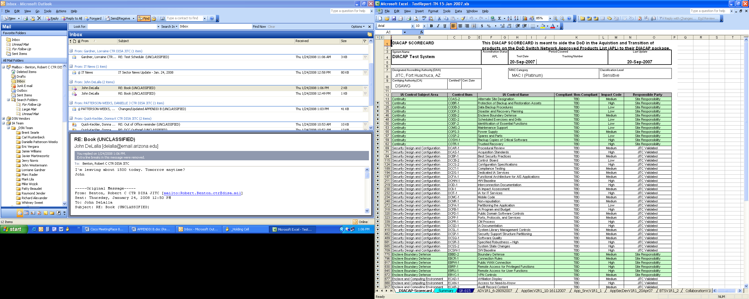

Figure A-1. Toggle Buttons

The SAR Scorecard is designed to pull findings from the checklists, associate them to the appropriate RMF Controls, and provide access to additional information in the finding notes. Scorecards for each product are supplements of this report and were provided in separate correspondence.

APPENDIX B. Acronym List

Acronym List
a | Part of version
ASR | Aggregation Services Route
CAT | Category
CS | Cybersecurity
DoDI | Department of Defense Instruction
DTR | Desktop Review
ESC | Enterprise Session Controller
ESXi | Elastic Sky X Integrated
FW | Firewall
GCT | Global Certification Team
ICR | Internal Compliance Review
ID | Identification
IPSEC | Internet Protocol Security
ISE | Identity Services Engine
ISR | Integrated Services Router
IWG | Interworking Gateway
LSC | Local Session Controller
NA | Not Applicable
Nmap | Network Mapper
NTP | Network Time Protocol
POA&M | Plan of Action and Milestones
R | Release
SBC | Session Border Control
sc | Security Center
SRG | Security Requirements Guide
SSH | Secure Shell
STIG | Security Technical Implementation Guide
SUT | System Under Test
TCP | Transmission Control Protocol
TN | Tracking Number
UDP | User Datagram Protocol
v | version
W-RAE | With Required Ancillary Equipment
W/O-RAE | Without Required Ancillary Equipment

